EXAMINATION TWO (TOTAL MARKS 110)

Name: \_\_\_\_\_\_\_\_\_\_\_\_\_\_\_\_\_\_\_\_\_\_ Class: \_\_\_\_\_\_ Date: \_\_\_\_\_\_

SECTION A: MULTIPLE CHOICE QUESTIONS (total marks 40)

Answer all questions on the Multiple Choice Answer Sheet.

Question 1

Which of the following statements regarding the crossing of plasma membranes by molecules is not true?

1. Small non-polar molecules cross easily by diffusion.
2. Lipid-soluble molecules cross the membrane easily.
3. Carbon dioxide moves out of the cell through the membrane, down a concentration gradient.
4. Small ions move readily through the phospholipid bilayer.

Use the following diagram to answer questions 2 and 3.

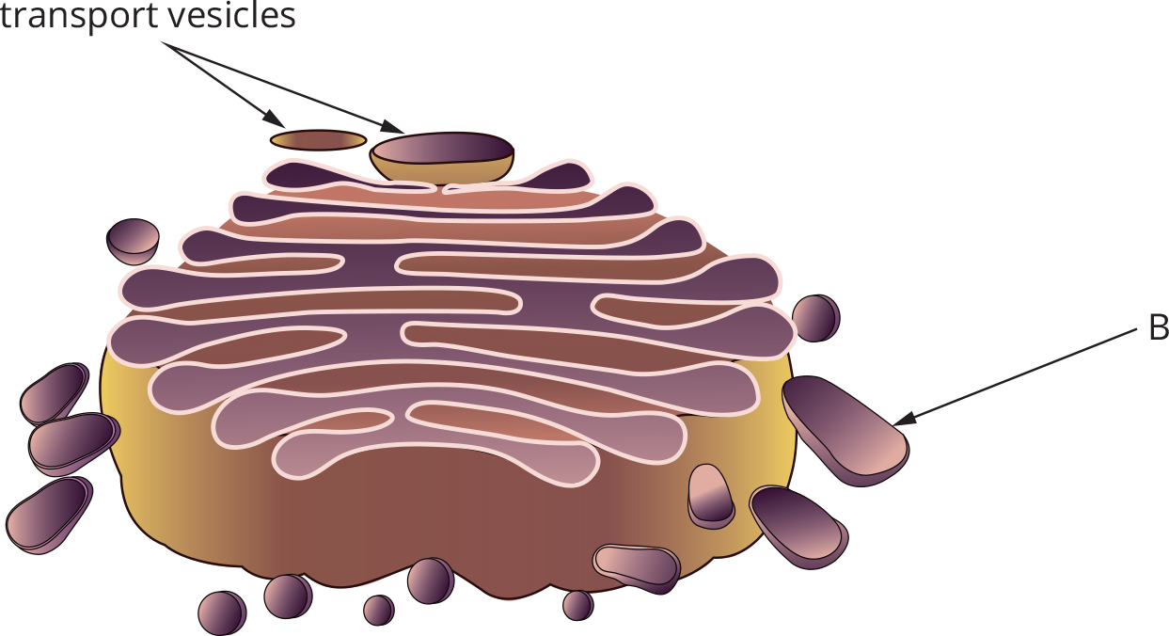

Question 2

In the structure illustrated, the transport vesicle could

1. be carrying lipids.
2. be carrying protein from free ribosomes.
3. contain proteins modified in the smooth endoplasmic reticulum.
4. be transporting proteins modified in the rough endoplasmic reticulum.

Question 3

Substances contained in structure B could be all of the following *except*

1. antibodies.
2. neurotransmitters.
3. a steroid hormone.
4. a protein hormone.

Question 4

A group of students are investigating the crossing of membranes. They have set up a model cell using dialysis tubing to simulate the cell membrane. This tubing is selectively permeable, like a plasma membrane. However, unlike the plasma membrane, permeability is based solely on size. The experimental equipment is shown in the diagram below. The solution in the dialysis tubing is 5% sucrose solution, and the surrounding solution is 10% sucrose solution. Sucrose is small enough to pass through the membrane but will do so quite slowly. What will happen to the volume in the thistle funnel?

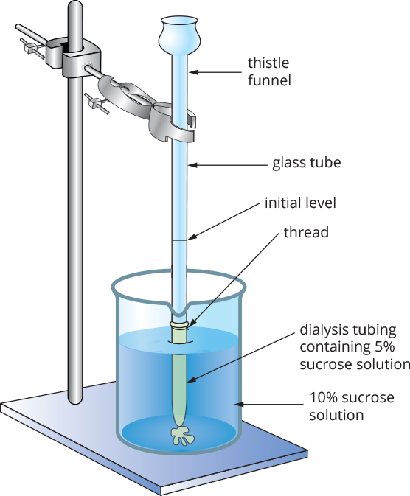

1. There will be no change.
2. Initially it will increase in volume.
3. Initially it will decrease in volume and then it will increase.
4. Initially it will increase in volume and then it will decrease.

Question 5

The main function of the light-dependent reactions of photosynthesis is to

1. produce ATP and NADPH.
2. produce glucose from CO2 and H2O.
3. produce NADPH for use during respiration.
4. use ATP to build glucose.

Question 6

Herbicides and poisons are used in agriculture to reduce the number of pest plant species. Pest plants compete with crop plants for space, light and soil nutrients, thereby reducing crop yields. The herbicide Gramoxone® is highly poisonous to all plants. It can be sprayed directly onto pest plants, which it then kills by disrupting the light-dependent reactions of photosynthesis. Which of the following processes would be hindered by Gramoxone®?

1. the production of chlorophyll in chloroplasts
2. the formation of ATP using the electron transport chain
3. the combination of H+ and CO2 to produce glucose and water
4. the formation of NADH using H+ from the splitting of water

Question 7

The Calvin cycle occurs in chloroplasts, in the

1. grana.
2. stroma.
3. chlorophyll.
4. thylakoid.

Question 8

During glycolysis, when glucose is broken down to form pyruvate, most of the energy of the glucose is

1. retained in the pyruvate.
2. lost as heat.
3. used to make ATP.
4. stored in the NADH that is produced.

Question 9

The most common hydrogen carrier in eukaryotic cells is

1. FAD.
2. NAD.
3. NADP.
4. acetyl co-A.

Question 10

In an experiment to investigate respiration in yeast, the yeast were initially grown in a glucose medium and supplied with oxygen. The yeast culture used 0.5 g of glucose per minute. After 10 minutes the oxygen flow to the culture was stopped. If the yeast continued to produce the same amount of ATP per minute, approximately how much glucose must it have been using per minute?

1. 3 g
2. 6 g
3. 9 g
4. 12 g

Question 11

Examine the following diagram of a cell.

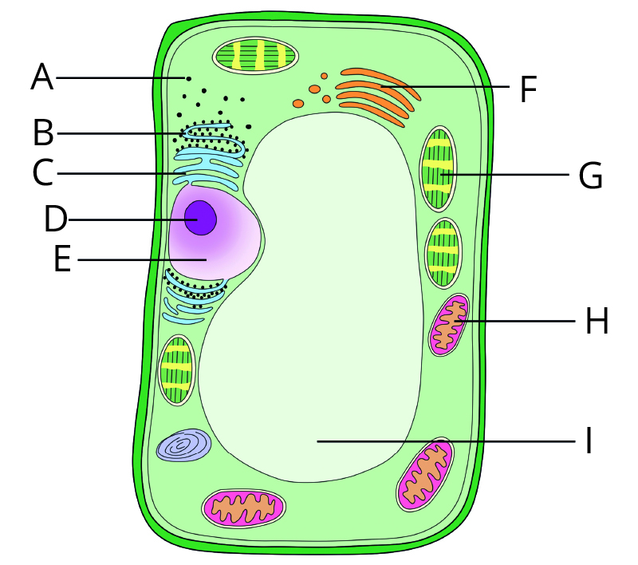

Source: © Mohd Suhail/Pearson India Education Services

DNA could be found in

1. organelles D, G, I and F.
2. organelles B, C and D.
3. organelles D, E, G and H.
4. organelles D, E and F.

Question 12

The presence of DNA in organelles other than the nucleus is evidence for the theory of endosymbiosis. This theory explains

1. where all eukaryotic organelles originated.
2. how viruses invade cells and incorporate their DNA into the cellular genome.
3. how cells absorb large external particles through endocytosis.
4. how mitochondria and chloroplasts evolved as a result of mutualistic relationships between separate, once free-living organisms.

Question 13

To study proteomics, a multidisciplinary research team of physiologists, biologists, chemists, geneticists, immunologists, pharmacists and others is needed, because the proteome consists of

1. all the genes in a particular organism.
2. all the enzymes and hormones in a cell.
3. all the organic polymers of an organism.
4. all the structural and functional proteins in cells and tissues of an organism.

Use the following information to answer questions 14–17.

Carbon dioxide is produced in mammalian cells as a result of cellular activities, including respiration. It must be excreted from the body. This happens in the lungs, and so the carbon dioxide must be transported there by the blood. Carbon dioxide has low solubility in water and limited affinity for haemoglobin, so most of it is transported in the blood as bicarbonate ions (HCO3‾). Blood and tissue fluid in a human are generally maintained in a narrow pH range, between 7.35 and 7.45. This means blood is slightly basic.

A family of enzymes called carbonic anhydrases are responsible for the conversion of CO2 to HCO3‾ in the tissues, and HCO3‾ back to CO2 in the lungs. Carbonic anhydrase II is responsible for the conversion of CO2 to HCO3‾.

Under normal circumstances, carbonic anhydrase can catalyse the change of CO2 to HCO3‾ at a rate of one million molecules per second. Imidazole is a chemical that inhibits the action of carbonic anhydrase II. It can enter the active site of the enzyme. An experiment was run at 37°C, with and without imidazole, at varying CO2 concentrations. The results are shown in the table.

|  |  |  |
| --- | --- | --- |
| CO2 concentration (millimol) | Rate of conversion | |
| Without imidazole (mmol/min) | With imidazole (mmol/min) |
| 0.1 | 3.2 | 1.6 |
| 0.2 | 4.5 | 2.7 |
| 0.3 | 6.7 | 4.1 |
| 0.5 | 7.1 | 6.3 |
| 1.0 | 8.8 | 7.8 |
| 2.0 | 10.3 | 10.1 |

Question 14

In this experiment

1. the dependent variable is the presence or absence of imidazole.
2. the concentration of CO2 is a controlled variable.
3. there are two independent variables.
4. 37°C is a dependent variable.

Question 15

The results of this experiment indicate that the type of inhibition shown by imidazole is

1. non-competitive.
2. competitive.
3. allosteric.
4. not possible to determine without more information.

Question 16

Which graph best shows the activity of carbonic anhydrase II as pH varies?

|  |  |
| --- | --- |
| **A** | **B** |
| C:\Users\K\Documents\Editing\Pearson\Heinemann Science\Editing\Edited\EDITED REDOWNLOADED FOR RESTYLING\JPEGs\HB12_5e_24_02_04Q.jpg | C:\Users\K\Documents\Editing\Pearson\Heinemann Science\Editing\Edited\EDITED REDOWNLOADED FOR RESTYLING\JPEGs\HB12_5e_24_02_05Q.jpg |
| **C** | **D** |
| C:\Users\K\Documents\Editing\Pearson\Heinemann Science\Editing\Edited\EDITED REDOWNLOADED FOR RESTYLING\JPEGs\HB12_5e_24_02_06Q.jpg | C:\Users\K\Documents\Editing\Pearson\Heinemann Science\Editing\Edited\EDITED REDOWNLOADED FOR RESTYLING\JPEGs\HB12_5e_24_02_07Q.jpg |

Question 17

As well as its polypeptide chain, carbonic anhydrase II also contains a zinc molecule in its structure. This makes this enzyme

1. a conjugate protein.
2. a tertiary-structured protein.
3. a secondary-structured protein.
4. a quaternary-structured protein.

Question 18

Chaperones are a group of proteins. The function of chaperones is to

1. assist DNA to coil correctly.
2. guide secretory vesicles to the cell membrane and assist exocytosis.
3. assist newly formed proteins to fold correctly.
4. break down prion proteins.

Question 19

During condensation reactions

1. monomers polymerise, and water is used.
2. proteins fold into their tertiary structure.
3. the bonds between the monomers of a polymer are broken.
4. bonds are formed between monomers, and water is produced.

Question 20

A signalling molecule (D) arrives at a cell, as shown below.

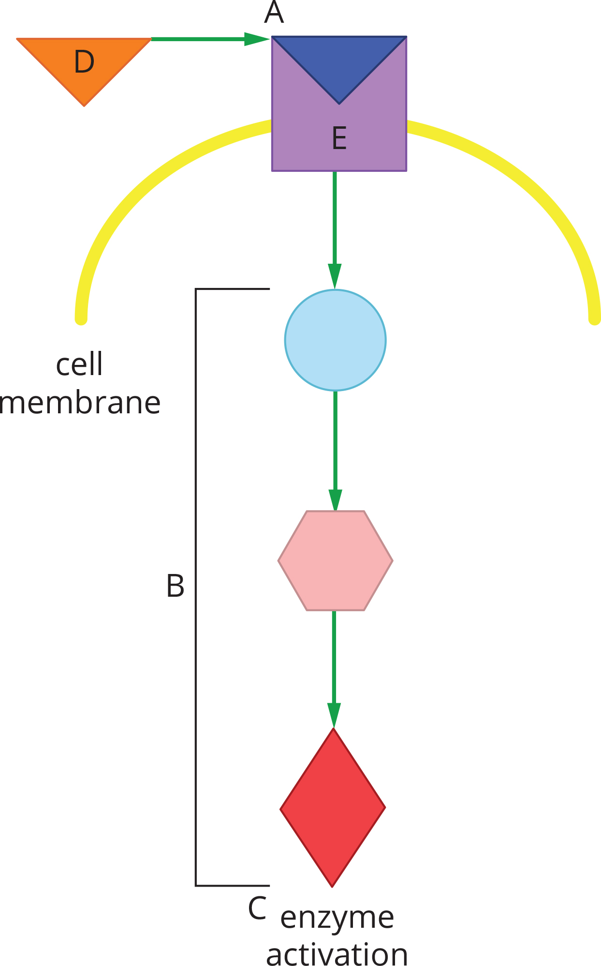

Based on the information in the diagram, which of the following statements is not true?

1. Structure E is the site of reception.
2. The signalling molecule is hydrophobic.
3. The molecules of B represent transduction.
4. Enzyme activation is the response to a stimulus.

Question 21

Neurotransmitters are released into the synapse at

1. the cell body.
2. the Golgi apparatus.
3. the pre-synaptic membrane.
4. the post-synaptic membrane.

Question 22

Innate immune response mechanisms are crucial to the survival of mammals because

1. the antibodies produced during the innate response protect the body from foreign antigens.
2. although the innate response is not specific, it is immediate.
3. the innate response is highly specific to the foreign antigens.
4. the innate response involves the action of leucocytes.

Question 23

In the adaptive immune response, Tc cells

1. become active only if they are stimulated by TH lymphocytes.
2. take over from natural killer (NK) cells in killing cells infected by viruses.
3. use perforin to perforate the cell membranes of virally infected somatic cells.
4. are responsible for stimulating B cells to differentiate and proliferate into plasma cells.

Question 24

In Australia, protection is available from many diseases that once caused many people to become ill and some to die. This protection comes in the form of a national vaccination program. One disease against which individuals are offered protection is measles. In most people, measles does not cause critical illness, but in a few individuals the measles virus can infect the brain, where it causes inflammation and death. The vaccination program involves one injection at 12 months and a second injection at 18 months.

Which graph best shows antibody levels following these injections?

|  |  |
| --- | --- |
| **A** | **B** |
| C:\Users\K\Documents\Editing\Pearson\Heinemann Science\Editing\Edited\EDITED REDOWNLOADED FOR RESTYLING\JPEGs\HB12_5e_24_02_09Q.jpg | C:\Users\K\Documents\Editing\Pearson\Heinemann Science\Editing\Edited\EDITED REDOWNLOADED FOR RESTYLING\JPEGs\HB12_5e_24_02_10Q.jpg |
| **C** | **D** |
| C:\Users\K\Documents\Editing\Pearson\Heinemann Science\Editing\Edited\EDITED REDOWNLOADED FOR RESTYLING\JPEGs\HB12_5e_24_02_11Q.jpg | C:\Users\K\Documents\Editing\Pearson\Heinemann Science\Editing\Edited\EDITED REDOWNLOADED FOR RESTYLING\JPEGs\HB12_5e_24_02_12Q.jpg |

Question 25

During the immune response, B lymphocytes with the ability to produce an antibody complementary to a non-self antigen become activated by

1. interaction with, and recognition of, the antigen presented by a TH cell.
2. interaction with, and recognition of, the antigen presented by an antigen-presenting cell.
3. interaction with, and recognition of, the antigen free in solution.
4. all of the above.

Question 26

Pertussis (whooping cough) is extremely dangerous to newborn infants. Even with modern hospital intervention, 1 in every 200 infants who contract it die, and a significant number of those who survive suffer irreversible brain damage as a result of the brain being starved of oxygen. Because of the immaturity of newborns’ immune systems, vaccinations are ineffective until after 8 weeks of age, and maternal antibodies do not provide protection.

The best protection for newborn babies from pertussis is

1. active immunity.
2. herd immunity.
3. passive immunity.
4. specific immunity.

Question 27

Plants have defences against invading pathogens. These defences include all of the following *except*

1. chitinases, which disrupt the cell membranes of fungi.
2. perforins, which rupture the cell membranes of bacteria.
3. tannins, which are toxic to insects.
4. defensins, which are toxic to microbes.

Question 28

The clearwing moth (Family: Sesiidae) and the yellow jacket wasp (Family: Vespidae) have very similar morphology. The moth mimics the wasp.

This similarity between the two species is an example of

1. divergent evolution as a result of genetic drift.
2. convergent evolution as a result of genetic drift.
3. divergent evolution as a result of natural selection.
4. convergent evolution as a result of natural selection.

Question 29

When Darwin went to the Galapagos Islands, he observed a number of groups of species. Among the groups were the giant Galapagos tortoises and the Galapagos finches. His observations helped him to formulate his ideas about the mechanisms of evolution.

The Galapagos finches

1. are the same today as when the ancestral finches arrived on the islands.
2. are a result of an adaptive radiation, where an original colonising population diversified to take advantage of a number of available niches.
3. developed as a result of regular gene flow between the mainland and the islands, along with mixing of populations between the islands.
4. demonstrate convergent evolution, as they were once distinct species that have grown more similar over time due to adaptation to similar niches and selection pressures.

Question 30

Consider the rock strata shown below. They are a representation of the sequences observed by palaeontologists at four sites separated by several hundred kilometres.

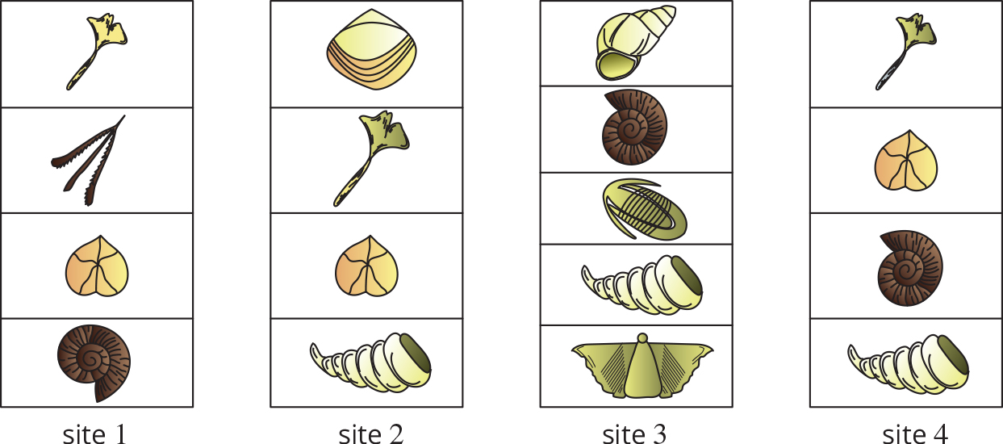

Observations of the fossils in the various layers indicate that the most ancient rocks can be found at

1. Site 1.
2. Site 2.
3. Site 3.
4. Site 4.

Question 31

Examine the evolutionary trees shown below.

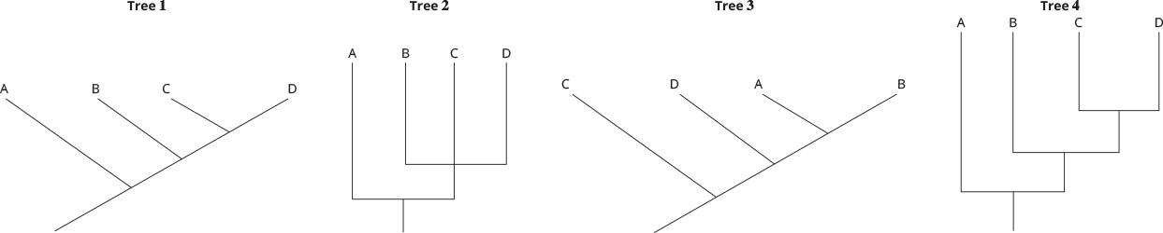

The two evolutionary trees that illustrate the same relationships are

1. Trees 1 and 2.
2. Trees 3 and 4.
3. Trees 1 and 4.
4. Trees 2 and 3.

Question 32

Each of the trees below shows a hypothesis as to where Homo denisovan should be placed on the tree of human evolution. The postulated denisovan line is drawn in blue.

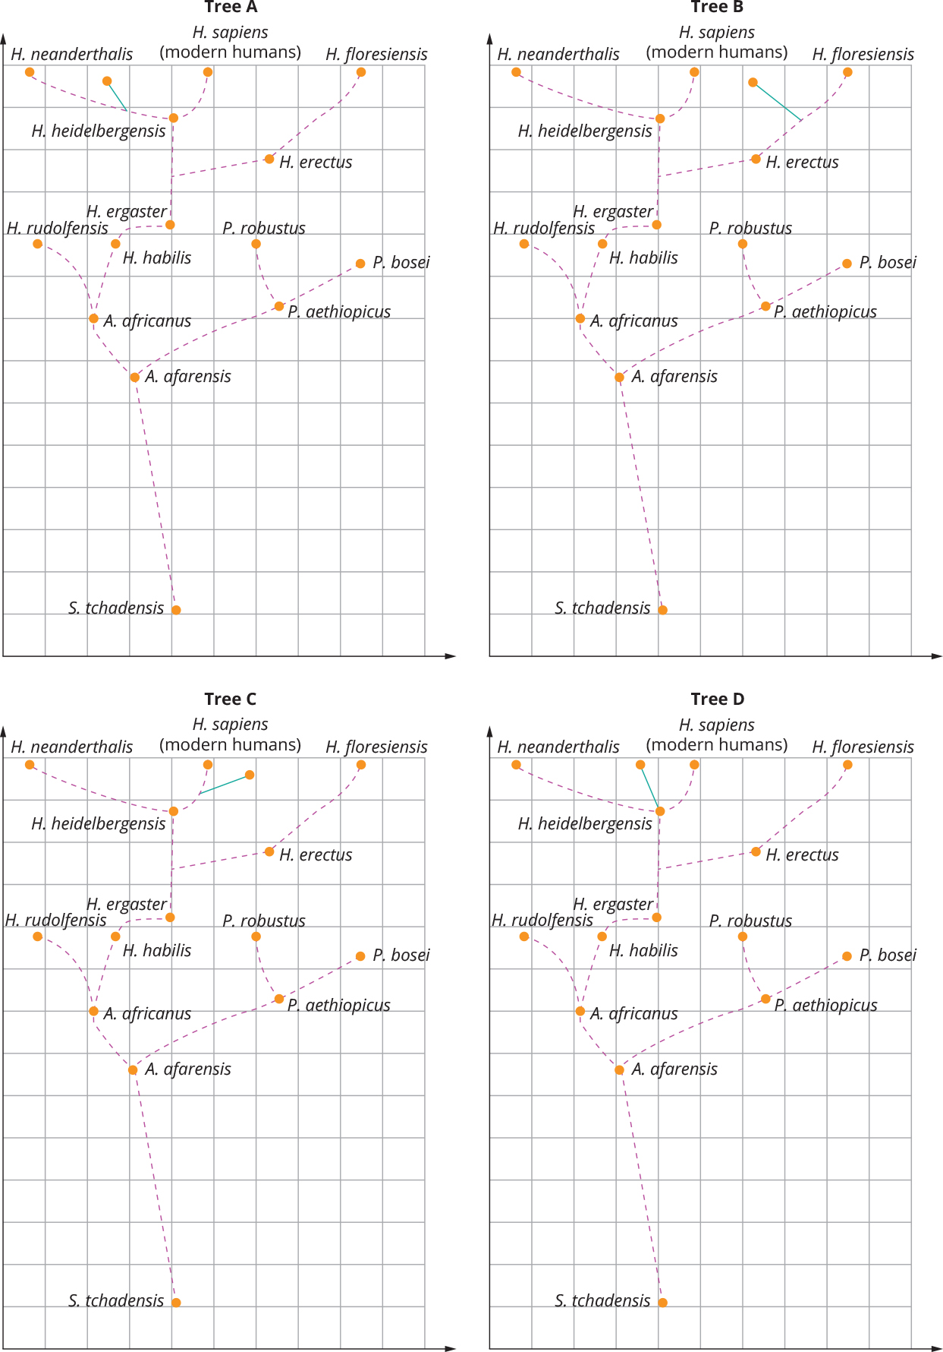

The tree that best represents the current thinking about the relationship between Homo sapiens*,* Homo neanderthalisand Homo denisovan is

1. Tree A.
2. Tree B.
3. Tree C.
4. Tree D.

Question 33

The DNA sequence of part of the mitochondrial DNA for five primate species is shown here.

|  |  |
| --- | --- |
| Species | DNA sequence |
| Homo sapiens | ACACCATA |
| Pan paniscus | ACACCATA |
| Gorilla gorilla | CCACCACA |
| Pongo abelii | CCACCACA |
| Nomascus concolor | CCACCATA |

From this data it would seem that

1. Pan paniscus is more closely related to Gorilla gorilla than Nomascus concolor.
2. Nomascus concolor and Pongo abelii are as closely related as Gorilla gorilla and Pan paniscus.
3. Homo sapiens is more closely related to Pan paniscus than any of the other species.
4. there is insufficient data to draw any conclusions.

Question 34

The hypothesis that Homo sapiens evolved in Africa is best supported by the finding that

1. the fossils of Australopithecus afarensis were found in Africa.
2. all members of Homo sapiens have the same number of chromosomes.
3. mitochondrial DNA is most variable in African populations.
4. the smallest number of mitochondrial mutations are found in the DNA of African populations.

Question 35

Skeletal evidence that a fossil hominin could *not* be a member of *Homo sapiens* would be

1. an opposable big toe.
2. a bowl-shaped pelvis.
3. cranial capacity greater than 1200 cubic centimetres.
4. a centrally positioned foramen magnum.

Question 36

Which of the following statements does *not* support the usefulness of molecular evidence when deducing the evolutionary relationships between organisms?

1. Molecular evidence can inform the development of phylogenetic trees.
2. Many genes evolve at a known and constant rate, known as the molecular clock.
3. Genes can undergo reverse mutations, wiping out evidence of an earlier mutation.
4. The gene for cytochrome c is more similar between humans and chimpanzees than it is between humans and rhesus monkeys.

Question 37

Tumour suppressor genes

1. stimulate the cell to divide.
2. are often over-expressed in tumour cells.
3. are activated by viral infection of the cell.
4. often encode enzymes that are involved in the repair of DNA damage.

Question 38

The traps of a venus fly trap, the spines of a cactus and the tendrils of a pea plant are all modified leaves.

These structures are

1. analogous.
2. homologous.
3. vestigial.
4. homozygous.

Question 39

Homeotic genes

1. are master genes that organise the development of the various segments of the animal body.
2. are genes that, through alternative splicing, form a variety of different proteins.
3. are regulator genes that bind to operons in prokaryotes.
4. are not found in humans.

Question 40

Genetic engineering of plants for resistance to many harmful factors in the environment has been the aim of a large number of scientists over past decades. The aim of their research is to increase crop production while reducing the impact of agriculture on the environment. One trait that has been artificially incorporated into the genomes of crop plants is resistance to glyphosate. Glyphosate is a herbicide that is sprayed onto crops to reduce the growth of weeds. Weeds reduce the yield from crops, because they compete with the crops for water, nutrients and light. The gene that conveys this resistance was originally identified in Agrobacterium.

Crops that have been engineered to have glyphosate resistance are best described as

1. transgenic.
2. genetically modified.
3. genetically modified and transgenic.
4. neither genetically modified nor transgenic.

SECTION B: SHORT ANSWER QUESTIONS (Total marks 70)

Answer all questions in the spaces provided.

Question 1 (Total marks 11)

Cells require energy. Most of that energy is provided by the mitochondria. Malfunctions of the mitochondria lead to serious problems for the cell and, hence, the organism. A laboratory performed a series of experiments to investigate the metabolism of mitochondria. For these experiments, mitochondria were isolated from cells and used in isolation. In all cases, mitochondrial activity was quantified by measuring oxygen uptake and carbon dioxide output.

a **i** Why were isolated mitochondria used, rather than whole cells? 1 mark

1. Why can the uptake and output of O2 and CO2 respectively be used as a measure of mitochondrial action? 1 mark

b In the first experiment, two cultures of mitochondria were used; one culture was supplied with glucose and the second culture was supplied with pyruvate. All other conditions were kept the same. The results of the experiment are shown in the table below. Gases were measured in arbitrary units and all experiments were carried out at 20°C.

|  |  |  |  |  |
| --- | --- | --- | --- | --- |
| Time (mins) | Mitochondria and glucose | | Mitochondria and pyruvate | |
| O2 uptake | CO2 output | O2 uptake | CO2 output |
| 5 | 2 | 2 | 10 | 10 |
| 10 | 0 | 0 | 10 | 10 |
| 15 | 0 | 0 | 10 | 10 |
| 20 | 0 | 0 | 10 | 10 |
| 25 | 0 | 0 | 10 | 10 |
| 30 | 0 | 0 | 10 | 10 |

1. Why must all factors except the glucose/pyruvate be kept the same? 1 mark
2. Why were the mitochondria given glucose so inactive, while those given pyruvate were very active? 2 marks
3. Why did the mitochondria given glucose show a small amount of activity at the beginning of the experiment and then stop? 2 marks
4. What differences in the results would you have expected if the experiment had been carried out at 5°C? Explain. 2 marks

c **i** State how much ATP would be produced per molecule of pyruvate given to the mitochondria. 1 mark

1. Where in the mitochondria is the ATP produced? 1 mark

Question 2 (Total marks 6)

Operons are common in bacteria. Since the *lac* operon was first identified, many more operons have been discovered. One of these is the arabinose operon. Many bacteria preferentially use glucose as an energy source but most are not confined to it. Some bacteria, including E. coli, are able to use arabinose. Arabinose is a sugar that forms part of the cell wall of plants.

The arabinose (ara) operon is shown below. In this operon araB, araA and araD code for enzymes needed to break down arabinose, and araC codes for a small peptide formed from two monomers.

If there is no arabinose available, the protein coded for by araC causes the DNA in that area to form a loop by binding the operator to the initiator. This stops RNA polymerase from attaching to the araBAD promoter.

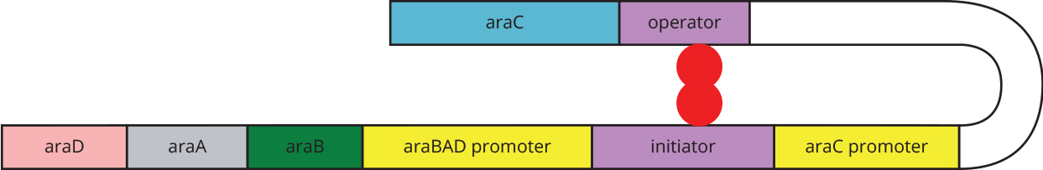

If arabinose is present, some will bind to araC, resulting in the opening of the loop, and the DNA is linear.



a Which gene or genes of the *ara* operon are structural? 1 mark

b Explain how a mutation in the initiator sequence would affect the activity of the structural genes of the ara operon. 2 marks

c Describe how the binding of arabinose to araC results in the breakdown of arabinose in the cell. 1 mark

d Both the ara operon and the lac operon provide E. coli with required nutrients.

1. What is one other way in which they are the same? 1 mark
2. What is one difference in their operation? 1 mark

Question 3 (Total marks 10)

Enkephalins are neurotransmitters. There are two enkephalins: met-enkephalin and leu-enkephalin. Both forms of enkephalin are a chain of five amino acids: tyr-gly-gly-phe and then either met or leu. Both enkephalins are products of the same gene, the pro-enkephalin gene. This gene has four exons and is found on chromosome 8.

Enkephalins are released by inhibitory neurons. They work by attaching to receptors on the pre-synaptic knob of a sensory neuron. They work by making the generation of an action potential much more difficult, as they change the electrical charge on the membrane. This inhibits the sending of pain signals to the brain.

**a** Explain how one gene could produce two different proteins. 2 marks

**b** How many bases make up the mRNA of leu-enkephalin, not including the cap and tail? 1 mark

Enkephalins attach to opioid receptors in the brain and thus have a similar effect on the body to opiate drugs such as morphine. A doctor is interested in seeing whether enkephalin can reduce pain in patients without the addictive side effects of morphine. In order to do this, the doctor wishes to make a copy of a suitable gene that can be placed into bacteria to produce large amounts of the protein to be tested.

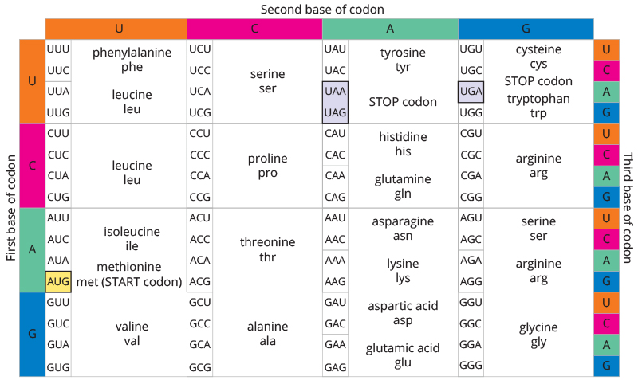

**c** Use the table above as the basis for making a suitable DNA molecule to make   
met-enkephalin. 2 marks

Another neurotransmitter is acetylcholine. It is most active in the motor system, where it causes muscles to contract. During surgery it is important to ensure that the patient remains still, and so a chemical that is very similar to acetylcholine is used to induce paralysis. While succinylcholine is chemically very similar to the neurotransmitter acetylcholine, its action is very different. Acetylcholine causes muscles to contract; succinylcholine prevents contraction. Great care needs to be taken with the administration of succinylcholine, as too large a dose will paralyse the chest muscles, causing death through asphyxiation.

**d** Suggest how succinylcholine inhibits muscle contraction. 2 marks

The diagram below shows the structure of the receptor for acetylcholine.

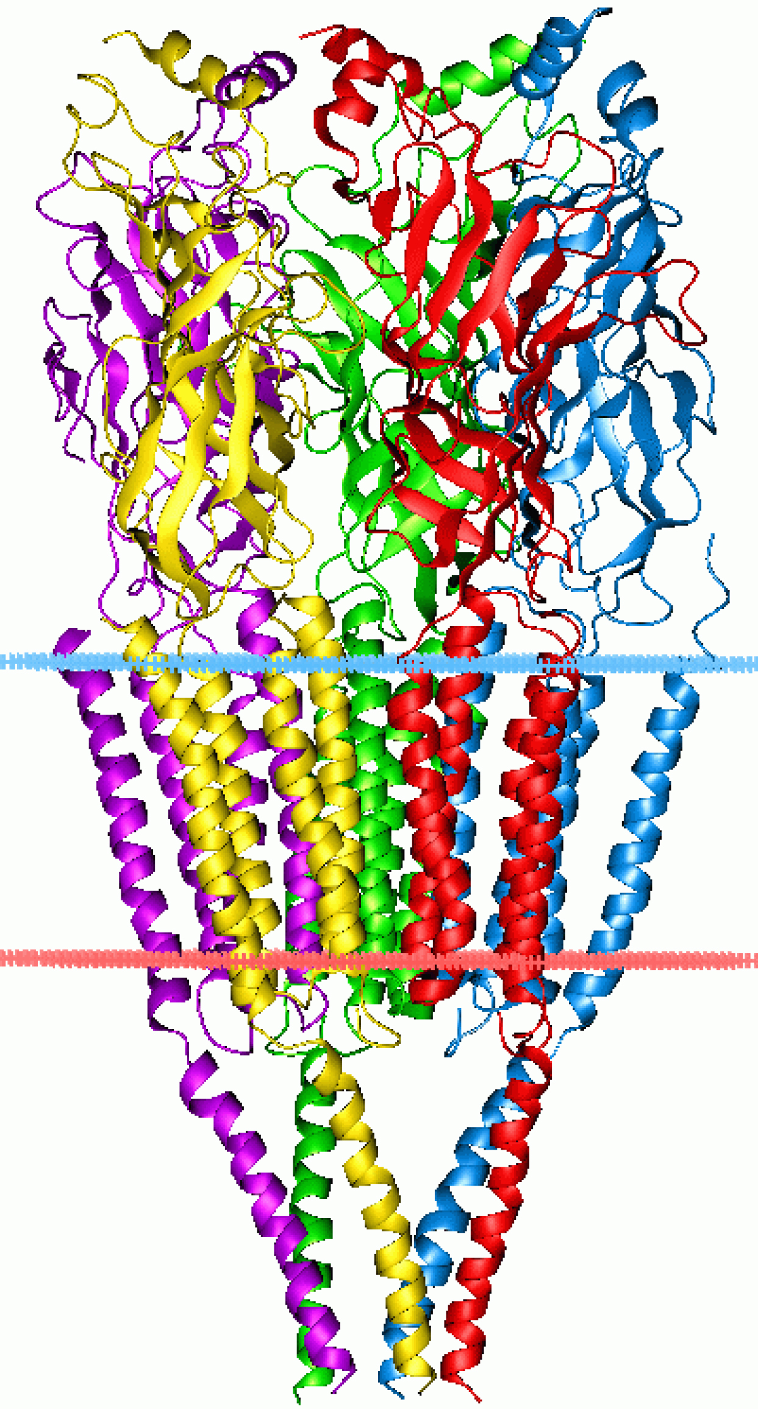

Source: © Andrei Lomize

e **i** What level of protein structure is shown? 1 mark

1. Label an α helix, a β pleated sheet and a random coil on the diagram. 2 marks

Question 4 (Total marks 5)

a Allergic reactions involve the chemical histamine. Histamine is a signalling molecule derived from the amino acid histidine.

1. What is the role of histamine in an anaphylactic reaction? 2 marks
2. One important treatment of allergic reactions is the use of antihistamines. How might antihistamines reduce the allergic response? 1 mark

**b** The cell below is a plasma cell. Organelles visible in the cell include the nucleus, Golgi complex, endoplasmic reticulum and mitochondria.

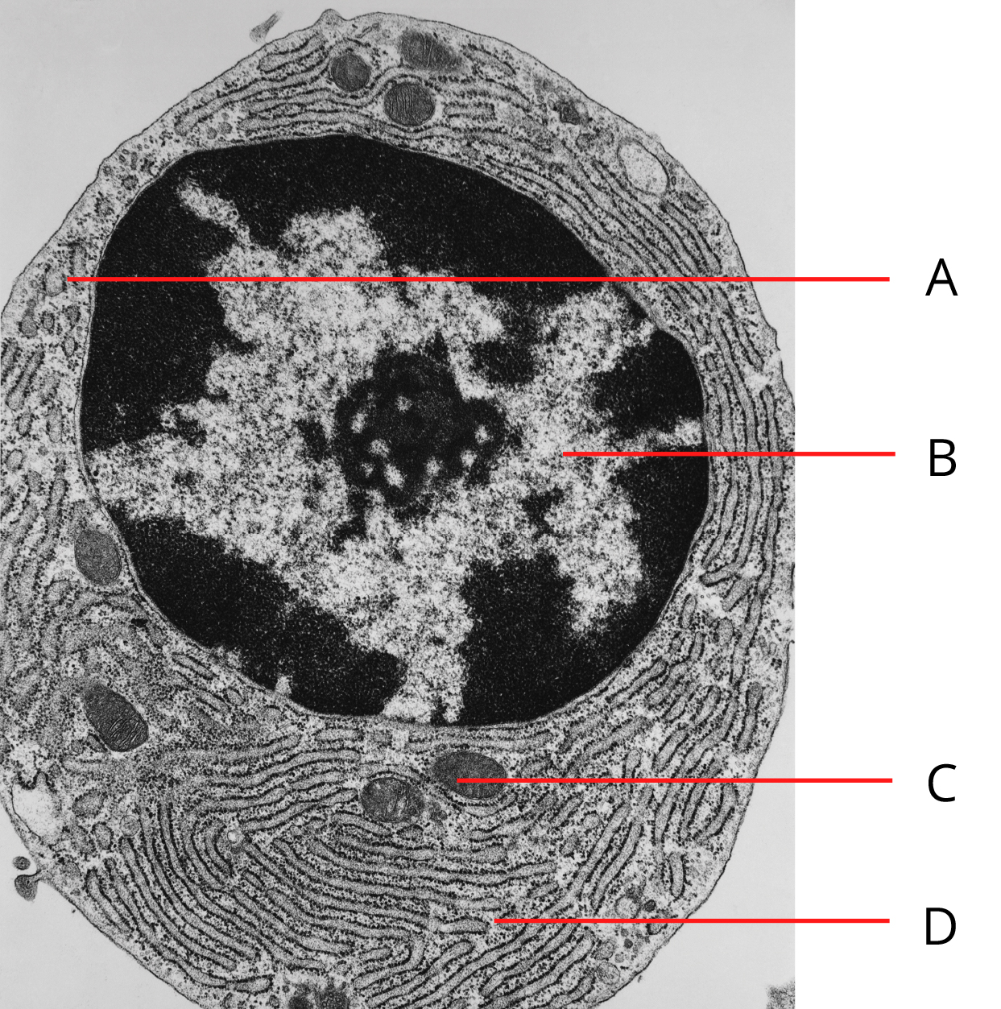

Source: © Don W Fawcett/Getty Images

Explain the roles of the organelles A and D in the allergic reaction. 2 marks

Organelle A

Organelle D

Question 5 (Total marks 7)

A scientist performed an experiment to investigate B and T cells in mammals. The scientist treated four rabbits with chemicals that destroyed their bone marrow. The rabbits were then treated as follows:

Rabbit 1 – no treatment

Rabbit 2 – injected with B cells only

Rabbit 3 – injected with T cells only

Rabbit 4 – injected with B and T cells

All four rabbits were then exposed to an adenovirus (cause of the common cold) and their antibody production to the virus was monitored.

**a** Explain how the destruction of the bone marrow would affect the rabbits’ immune systems. 2 marks

b **i** Which of the rabbits would produce antibodies against the virus? 1 mark

1. Explain your reasoning. 2 marks

**c** Why is rabbit 1 included in the experiment? 1 mark

**d** What is one major limitation of this experiment? 1 mark

Question 6 (Total marks 6)

A group of students were interested in the conditions that increase the chance of fossilisation occurring. One factor that they thought could be important was the pH of the soil in which the organism was buried. In order to investigate this, the students designed an experiment.

They weighed three pidgeon femurs and then placed the bones into solutions of different pH, to simulate the soil conditions in soils of different pHs.

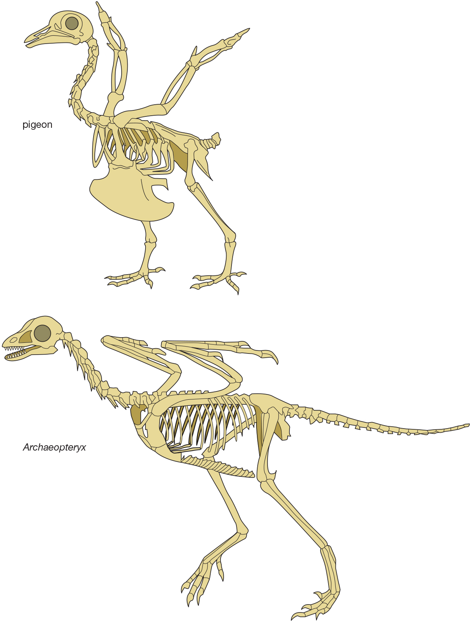

Their results are shown in the table below.

|  |  |  |  |  |  |  |
| --- | --- | --- | --- | --- | --- | --- |
| pH | Weight (g) | | | | Decrease in weight after 9 days | |
| Initial | After 3 days | After 6 days | After 9 days | Total (g) | % |
| 4.0 | 24.1 | 22.8 | 21.9 | 18.7 | 5.4 | 22.4 |
| 4.5 | 23.9 | 22.2 | 21.1 | 19.8 | 4.1 | 17.2 |
| 5.0 | 24.9 | 24.0 | 23.1 | 24.2 | 0.7 | 2.8 |
| 5.5 | 24.3 | 23.9 | 23.3 | 22.9 | 1.4 | 5.8 |
| 6.0 | 23.8 | 23.4 | 23.0 | 22.6 | 1.2 | 5.0 |
| 6.5 | 24.5 | 24.1 | 23.8 | 23.4 | 1.1 | 4.5 |
| 7.0 | 23.6 | 23.5 | 23.2 | 23.0 | 0.6 | 2.5 |
| 7.5 | 24.7 | 24.4 | 24.2 | 24.1 | 0.6 | 2.4 |
| 8.0 | 24.2 | 23.9 | 23.7 | 23.5 | 0.7 | 2.8 |
| 8.5 | 23.9 | 23.6 | 23.2 | 22.8 | 1.1 | 4.6 |
| 9.0 | 23.7 | 23.4 | 23.0 | 22.7 | 1.0 | 4.2 |

a **i** What trends are evident in the data? 1 mark

1. Comment on any unreliable data points. 1 mark

**b** What does the data indicate about the conditions needed to preserve bones long enough for the bones to fossilise? 1 mark

**c** Identify two other factors likely to lead to good fossil formation. 1 mark

In order to trace the development of life on Earth, it is necessary to know when the fossilised organisms lived. Radioactive dating methods are used to date the fossils. One method of dating involves measuring the decay of 40K to argon. The decay curve for 40K/Ar is show below.

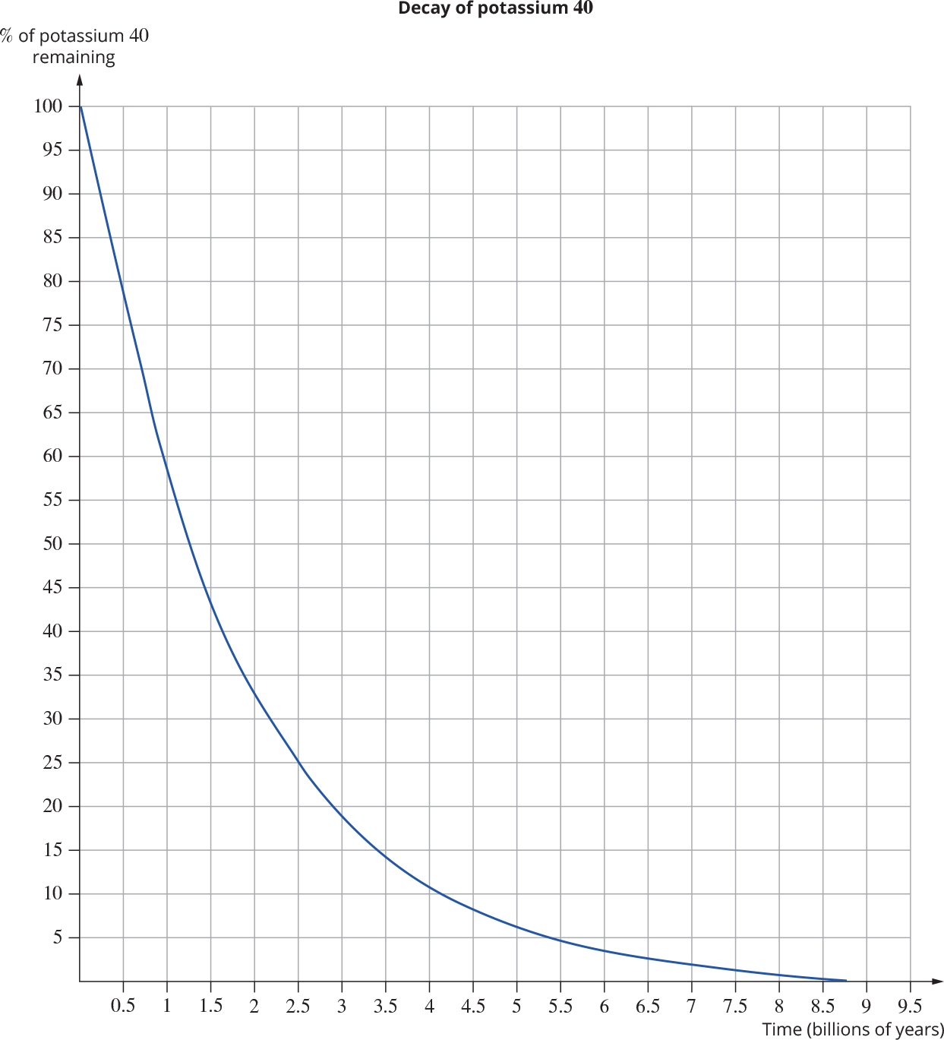

**d** A fossil bird bone was found. The layers of volcanic ash above and below the fossil were analysed for the concentration of 40K, and were found to be 95% and 90% respectively.

1. Why isn’t the fossil or its layer dated directly? 1 mark
2. How old is the fossil bone? 1 mark

Question 7 (Total marks 6)

Cells have receptors for a vast array of signalling molecules. One such receptor is called the human epidermal growth receptor (HER2). In around 25% of women with breast cancer, the gene for this receptor is over-expressed. This results in too much growth factor being received by the cells, and so they grow out of control, causing breast cancer. About 12.4% of all cancers are breast cancer, with most sufferers being female.

**a** The HER2 receptor is a transmembrane protein. What does this indicate about the chemical nature of the signalling molecules it receives? 1 mark

**b** Scientists have developed a drug called trastuzumab, which is marketed as Herceptin®. This drug is a monoclonal antibody.

1. What is a monoclonal antibody? 1 mark
2. The antibody blocks the HER2 receptor. Draw a labelled diagram showing how a monoclonal antibody can block a receptor. 2 marks
3. Without the constant stimulation to divide from the growth factor signalling molecules, the tumour cell stops dividing. In many cases the cell then undergoes apoptosis by the intrinsic pathway. Describe how the intrinsic pathway results in cell destruction. 2 marks

Question 8 (Total marks 10)

The quagga (Equus quagga quagga) is an extinct sub-species of the plains zebra. It had some distinctive features that set it apart from other members of the species. In particular, its upper parts were brownish rather than white. It also only had stripes on its head, neck and the front portion of its body.

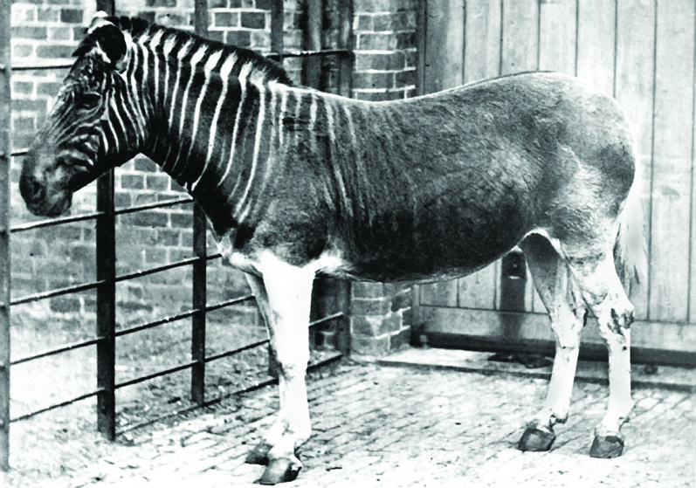

Source: © Frederick York

The last quagga died in 1883. A recent program has been instituted to try to bring back the quagga through selective breeding of members of the plains zebra. There are several preserved specimens of quagga in museums around the world. Quagga DNA profiles have been made from these specimens.

**a** Of what use are these profiles to breeders trying to re-create the quagga? Explain. 1 mark

**b** A hypothetical quagga DNA profile is shown below, along with the profiles of several possible breeding animals.

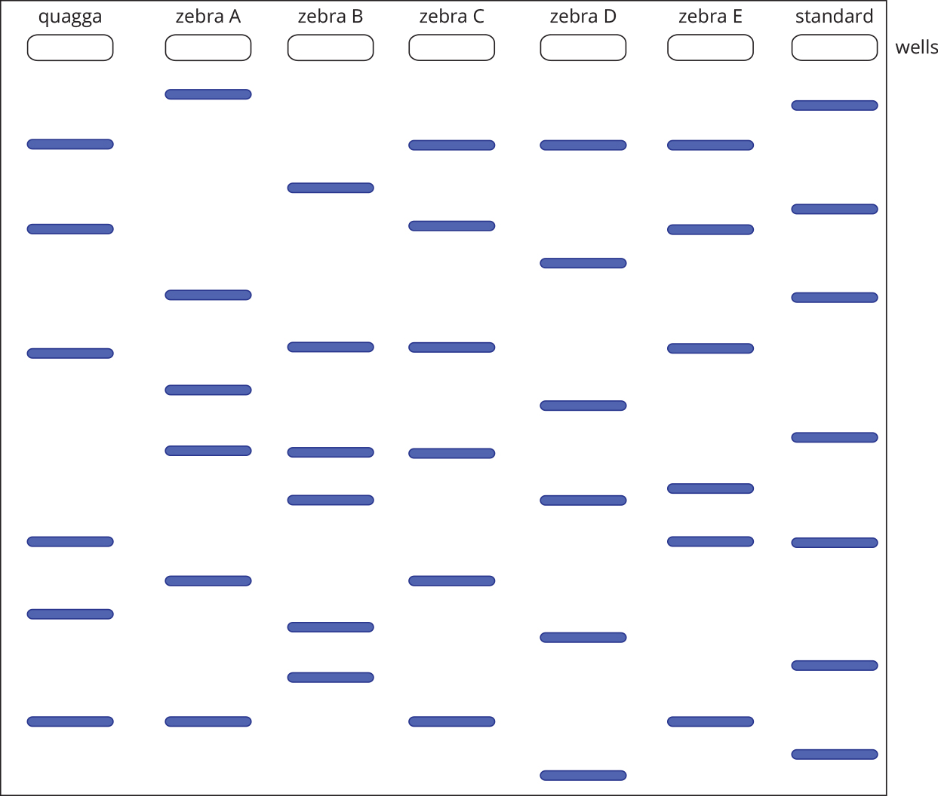

1. If zebras A and B are stallions (males), and C, D and E are mares (females), which two individuals would you bring into your breeding program in order to bring back the quagga? 1 mark
2. Explain why you chose these individuals. 2 marks
3. Evidence suggests that the original quagga population became separated from the parent population of plains zebra during the Pleistocene, about 120 000 to 290 000 years ago. Explain how the quagga became a distinct genetic group. 3 marks

c **i** Explain how efforts to re-create the quagga are an example of selective breeding. 1 mark

1. The most significant barrier to re-creating the quagga will be if the quagga population possessed some unique alleles. Explain why. 1 mark

**d** Many people would argue that no attempt should be made to resurrect the quagga, or any other species. Give at least one reason why people may hold that opinion. 1 mark

Question 9 (Total marks 9)

The human immunodeficiency virus (HIV) was one of the great challenges faced by the medical profession in the 20th century. Although no cure or vaccine has been found, HIV has now been reduced to a chronic disease, not a terminal one, at least for people treated in developed countries.

HIV has proved a difficult virus to deal with. It has many strains, as seen below, but not all of them infect humans. There is also strong evidence that HIV has entered the human population on several occasions, having been passed on from other primate species.

All human infections belong to five families of virus HIV 1 strains M, N and O, and HIV 2 strains A and B.

Consider the phylogenetic tree shown here.

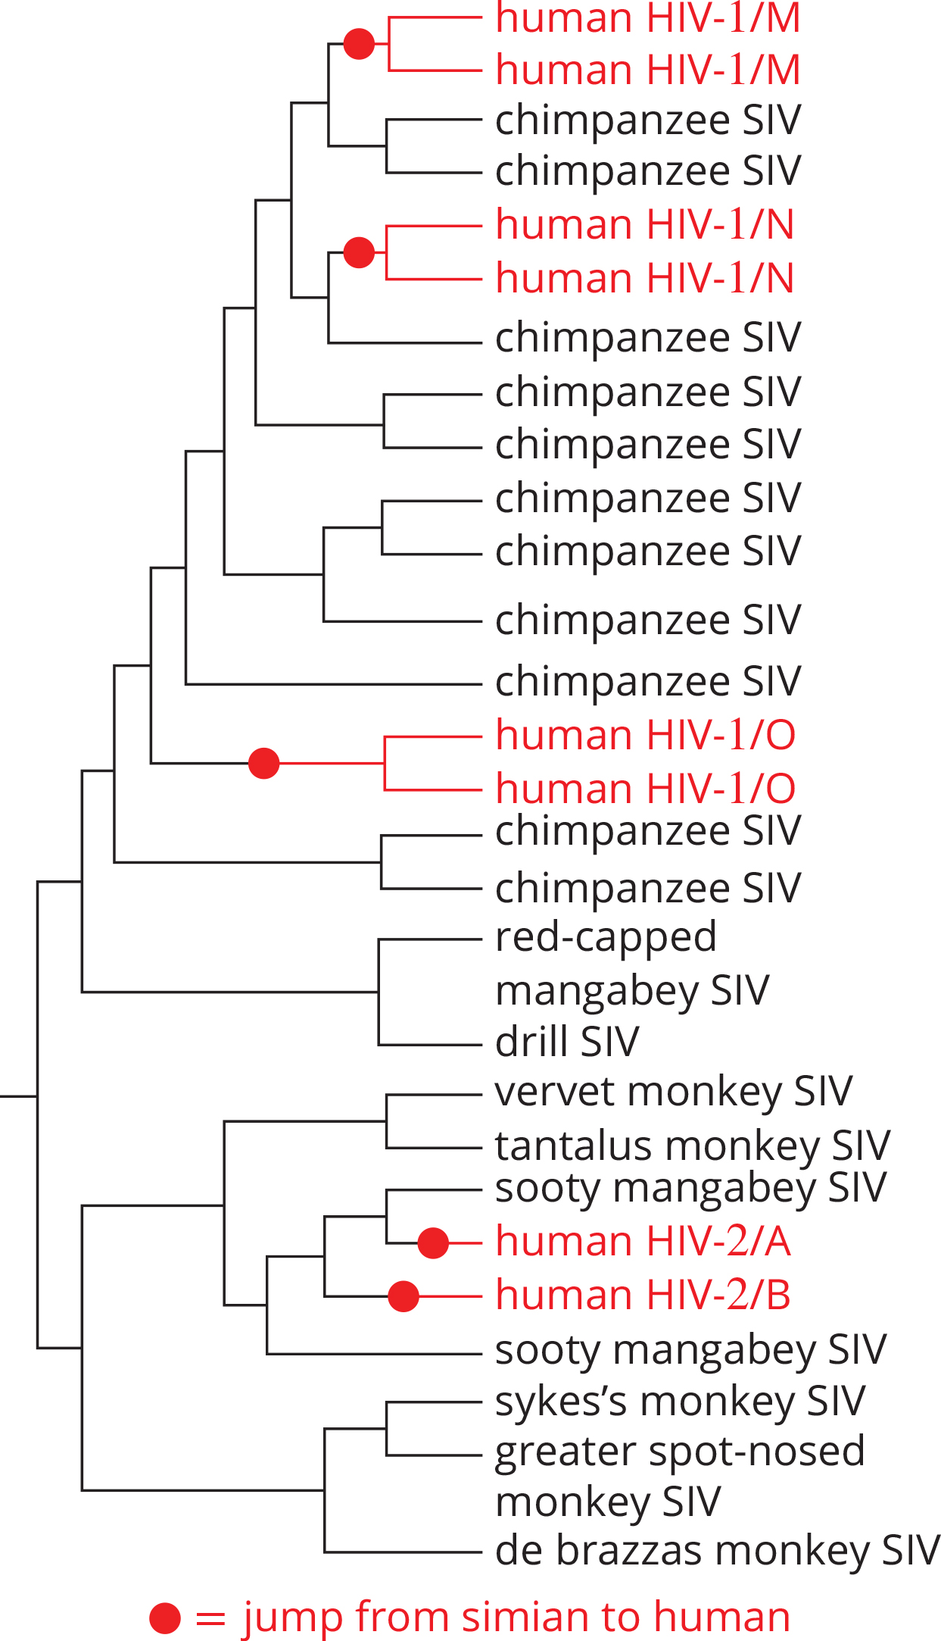

**a** From which species is it hypothesised that HIV 2 entered the human population? 1 mark

**b** Definitive diagnosis of patients with suspected HIV infection can be done using DNA profiling. However, before this process can be undertaken, reverse transcription and PCR must be performed on the nucleic acids. Explain why. 2 marks

**c** The most prevalent form of HIV attaches to a receptor on the surface of T cells in order to gain entry into the cell. Individuals homozygous for a defect in this receptor (CCR5) are highly resistant to HIV infection. These individuals are otherwise healthy.  
Explain how this information could be used to develop an antiviral treatment for HIV. 2 marks

**d** Currently there is no HIV vaccine available, only treatment once the disease has developed. The best scenario would be the development of a vaccine against HIV followed by a massive vaccination program in areas where the disease is prevalent.

1. Why is it so difficult to develop a vaccine for HIV? 1 mark
2. What do researchers need to find out about HIV in order to create an effective vaccine? 1 mark
3. Could a massive vaccination program such as the one that wiped out smallpox completely eliminate HIV forever? Explain your reasoning. 2 marks

End of Examination